1. Connect switch with minimum 6 devices that should include a DHCP server

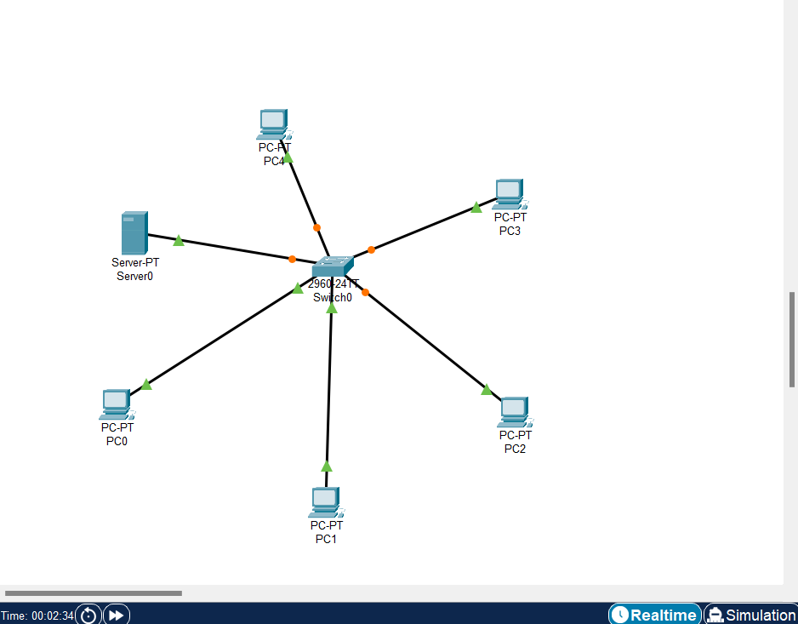

1. Connect another switch with minimum 3 devices

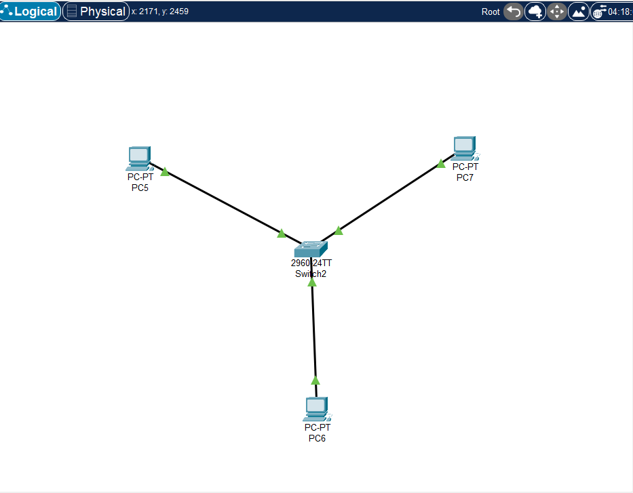

1. Connect 2 switches together

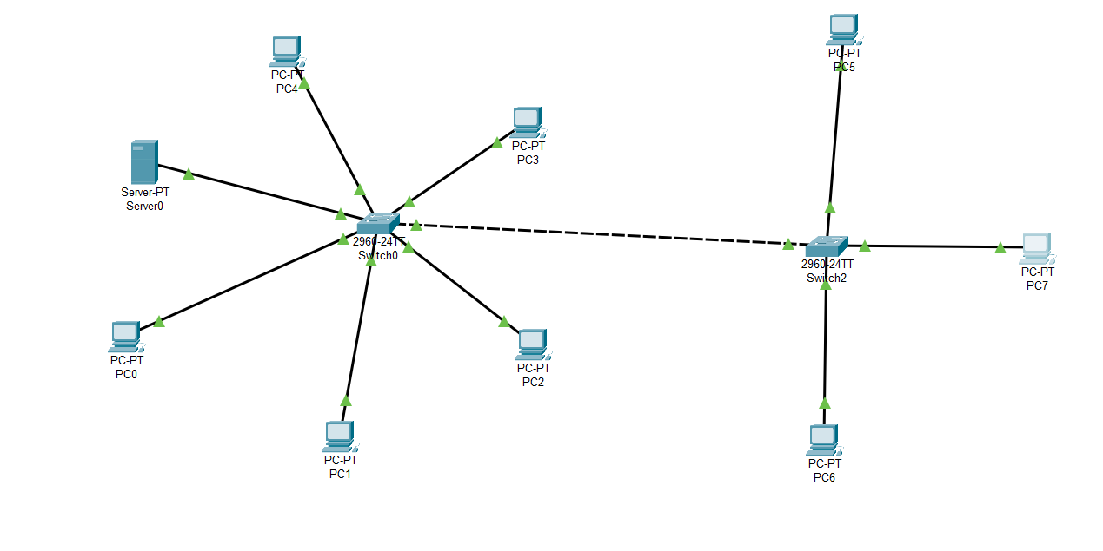

1. Devices in first switch should get IP Addresses from DHCP Server

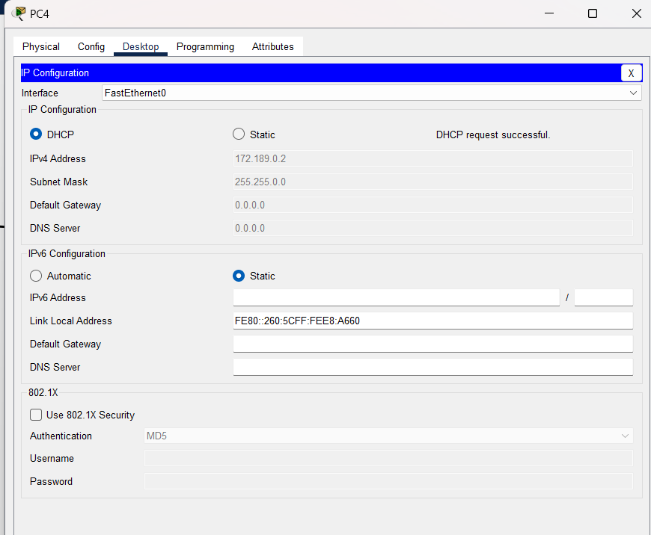

1. All the DHCP IP addresses should start from 259th usable IP of 172.17.0.0/23 network

* 259th Usable IP – 172.17.1.3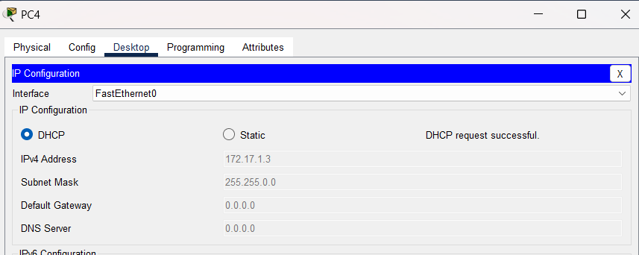

1. Manual IP Address should be assigned to DHCP Server and this should be one IP Address before the start of DHCP IP Addresses

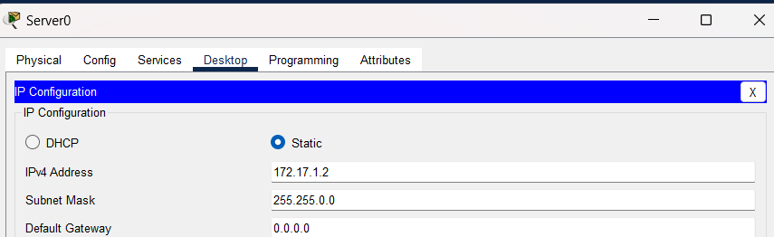

1. Manual IP Addresses should be assigned to devices of second switch

+

1. These IP Addresses should be from 509th usable IP of 172.17.0.0/23 network

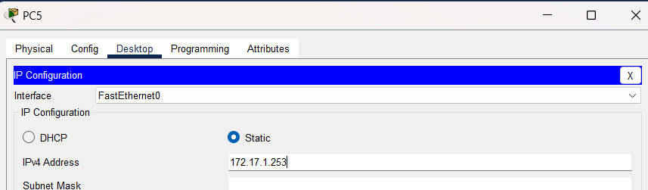

1. Ping from 259th IP Address device to 510th IP Address device, and write your observation below

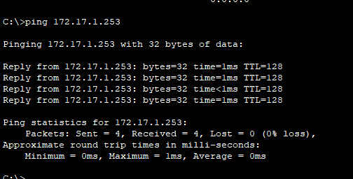

It is Pinging because they are in same network.

1. Disable the DHCP service and check which IPs the client devices receive

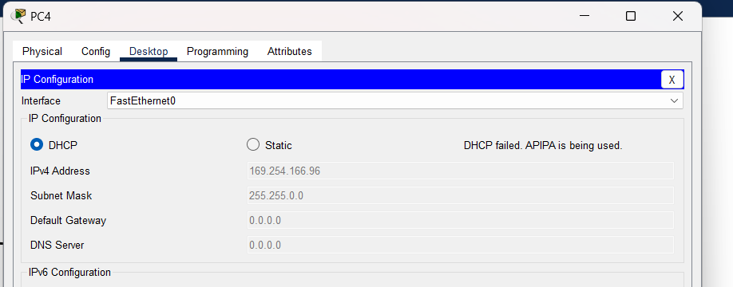

We are getting APIPA services – 169.254 series.

1. Ping the received IP addresses and write observation

Not pinging because AP IPA giving random generated IPS to system.

